[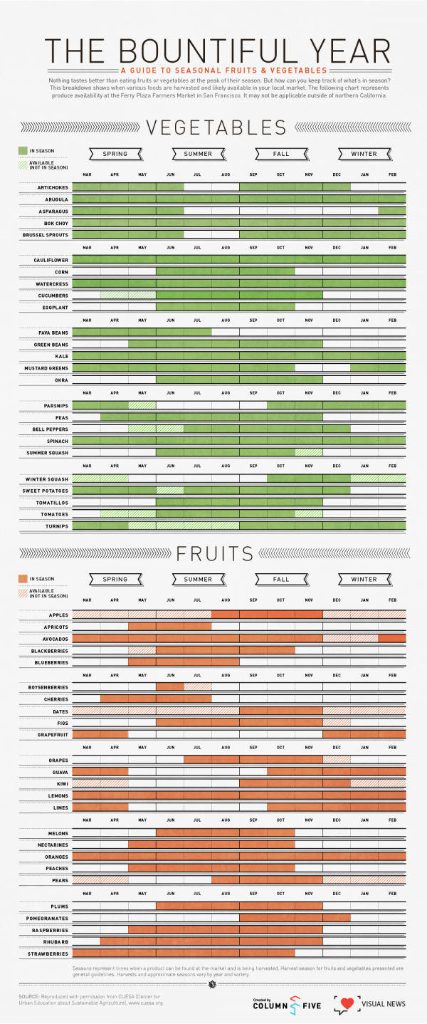](http://www.visualnews.com/2012/06/06/the-bountiful-year-a-visual-guide-to-seasonal-produce/?view=infographic)

[](http://www.visualnews.com/2012/06/06/the-bountiful-year-a-visual-guide-to-seasonal-produce/?view=infographic)