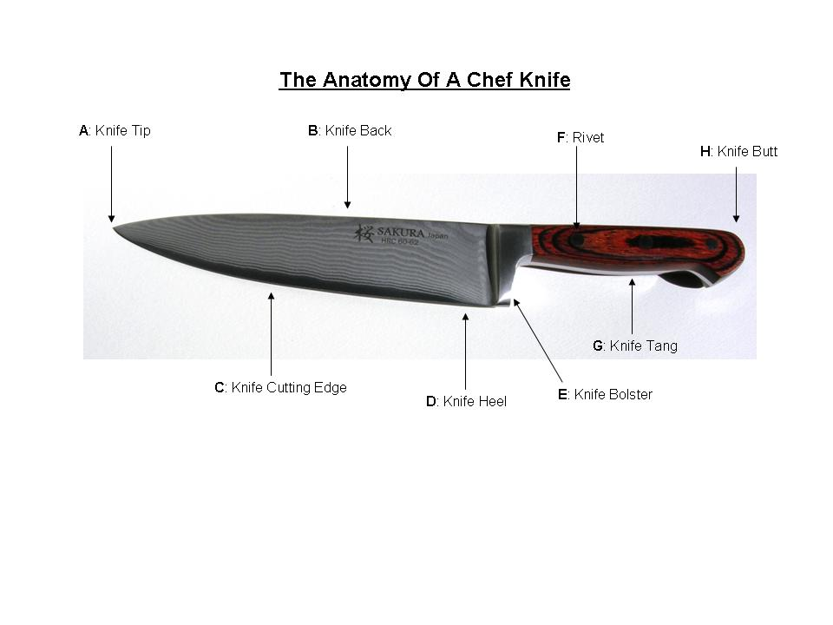Name__________________________Period______Date_________

Label the parts of the knife as shown in the drawing above.

A______________________________________________________

B______________________________________________________

C ______________________________________________________

D ______________________________________________________

E ______________________________________________________

F ______________________________________________________

G ______________________________________________________

H ______________________________________________________

C:\Users\Heather\AppData\Local\Microsoft\Windows\Temporary Internet Files\Content.IE5\CACO9BVI\MC900290049[1].wmfName___________________________Period_______Date_____________

**Knife Rules: Quick Draw**

List the reason for each knife rule listed below and illustrate each with a picture describing the rule.

|  |  |  |
| --- | --- | --- |
| **Rule** | **Reason** | **Picture** |
| Never point a knife at someone when you are talking. |  |  |
| When carrying a knife, hold the blade stiffly to your side with the blade facing back - Do NOT swing your arms. |  |  |
| Do not catch a knife if it falls; quickly step to the side and let it drop. |  |  |
| Always say "knife behind" when walking behind someone while carrying a knife. |  |  |
| Never leave a knife in the sink. |  |  |
| Keep knives sharp |  |  |
| Use wooden or plastic cutting boards when using a knife instead of metal, marble, or glass. |  |  |
| Store knives properly in a clean place like a knife kit, knife block, or magnetized rack. |  |  |

Knife Care and Storage

* Keep Knives ________________: Clean knives immediately after using them and don’t leave them lying in or near a ___________________.
* Work carefully when ___________________ the blade so you don’t cut yourself.
* NEVER leave any knife in a _________________ – it can cut someone who may not know the knife is in there.
* Keep Knives Sharp: A ___________________ knife performs better and is safer to use because less ___________________ is needed to cut through food.
  + When too much pressure is used, the knife can _________________, causing injury to the user.
  + ________________________ and sharpening stones can be used to keep knives sharp
* Use an Appropriate Cutting Surface: Cutting on metal, glass, or marble surfaces will __________________ and damage the blade of a knife.
  + To prevent dulling, always use wooden or __________________ cutting boards.
* Keep Knives Properly Stored: To avoid injury, contamination, or damage to your knife, store it properly in a clean place.
  + Knife ____________________
  + Knife kits or rollers
  + Knife racks
  + ____________________ holders

C:\Users\Heather\AppData\Local\Microsoft\Windows\Temporary Internet Files\Content.IE5\3P63XSUZ\MC900356987[1].wmfName________________________Period______Date___________

**Knife Video Guided Questions**

1. What motion should you use when slicing through foods?
2. How should your guiding hand be positioned on the food? Where should your pinky and thumb be located?
3. When cutting small or thin food items, what part of the knife should you cut with? (where on the knife blade?) Why is this helpful?
4. What degree should you hold your knife when honing it with the steel?
5. Name three types of knife cuts or sizes you heard in the video.

________________________________

________________________________

________________________________

1. How do you get the skin of garlic?