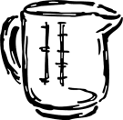
Kitchen Equivalents
Complete the equivalents charts below and on the back of this page. After you label each measurement, color or outline the box.
Gallon (gal): Red Quarts (qt): Dark Green Pints (pt): Yellow Cups (c): Blue
Tablespoons (Tbs): Orange Teaspoons (tsp): Purple Weight Ounces (wt. oz): Pink Fluid Ounces (fl oz): Light Blue

